Our Mission
By God’s Grace, West Parish Congregational Church, United Church of Christ, is committed to Nurturing and Celebrating God’s Love in our lives, in the Church Family, in the Community, and in the World.

June 2023 newsletter
Steeple View
West Parish Congregational Church
United Church of Christ


Pastor’s Perspective
Summer in Maine. There really is no place better during this season! We’re looking forward to having our grandson Lincoln on the weekends and trips to Sea Dogs games, the coast, hiking, etc. We will be venturing out of state to New Jersey for a family celebration of my mom’s 90th birthday and attending a Phillies game. And, at the end of the summer, a group of 10 from the church will be taking a pilgrimage to Iona, Scotland, during the first week of September. Our family will be extending the trip for a few days to visit with our son Ben and daughter-in-law Jess in Edinburgh.

What’s on your docket for the summer? At the church, Pentecost Sunday, May 28th, is the day when we remember the story of the Holy Spirit animating the followers of Jesus and prompting them to share the good news of Jesus. Then, on June 4th, we will celebrate our children and youth by having them take part in the service, including a special skit for Communion followed by fellowship time with ice cream. On that day, we will also be having an after-church conversation about the “Youth Cafe” teen drop-in center that will be starting in the Fall.

Later in the summer, the pianists from Music Without Borders will perform during worship and there will be opportunities for outdoor worship in August. I plan to do a summer preaching series of biblical story-telling, a new approach to preaching that I’ve been wanting to try. And there will be ample opportunities for fellowship and summer fun. Blessings and peace to you and your family and best wishes for a restful, Spirit-filled summer!

Tim

Christian Education

Friday evenings continue for our middle school youth group. We enjoy pizza dinners with Tim, playing games, and practicing a skit for Children’s Sunday on June 4. Our last Youth Group Friday is June 2.
It’s been wonderful to have this group of young people getting to know and feel comfortable with our church. The kids constantly remind us they feel like WPCC is home and they feel welcomed.
The CE Committee is making plans for next year’s children’s programming and education. We seek new members willing to be active with our youth.

Deacon’s Report
Items from the May Deaconate meeting:

Devotional Thoughts: Melinda Remington – Corinthians 13 – Melinda said it is so important to be in prayer and know that God answers the prayers. Gifts of the spirit are present, if we are open to receive them. – Love, Joy, Peace, Patience, Gentleness, Goodness, Faithfulness, Kindness, Self Control. And Love is the most important gift. Spiritual gifts are so important to share.

Report of Notes Sent: Beth Brough has sent 34 letters since March 1. She really enjoys the letter writing. (As a recipient myself of Beth’s beautiful, eloquent, thoughtful and insightful letters I received while my shoulder was healing, I can honestly say that any reader who is lucky enough to receive a card from Beth, their day has immediately been made better! Thank you Beth!) Ted also received a nice note from Peggy Paine.

Reflect on May 6th conference: Alive and Thrive – It was a great Conference led by Minister Marisa Laviola. Perhaps we need to change bylaws so that you don’t need to be church members to be on committees. Share ministry and mission with other churches, reaching out to congregations that need support. Face to face invitations get more response. Tim said we should figure out what to take that is most applicable to us as a church.



Children/Youth Sunday on June 4 - Christian Ed will sponsor an ice cream social following the service. The children will be performing a skit they have been practicing and then they shall serve communion following the skit.

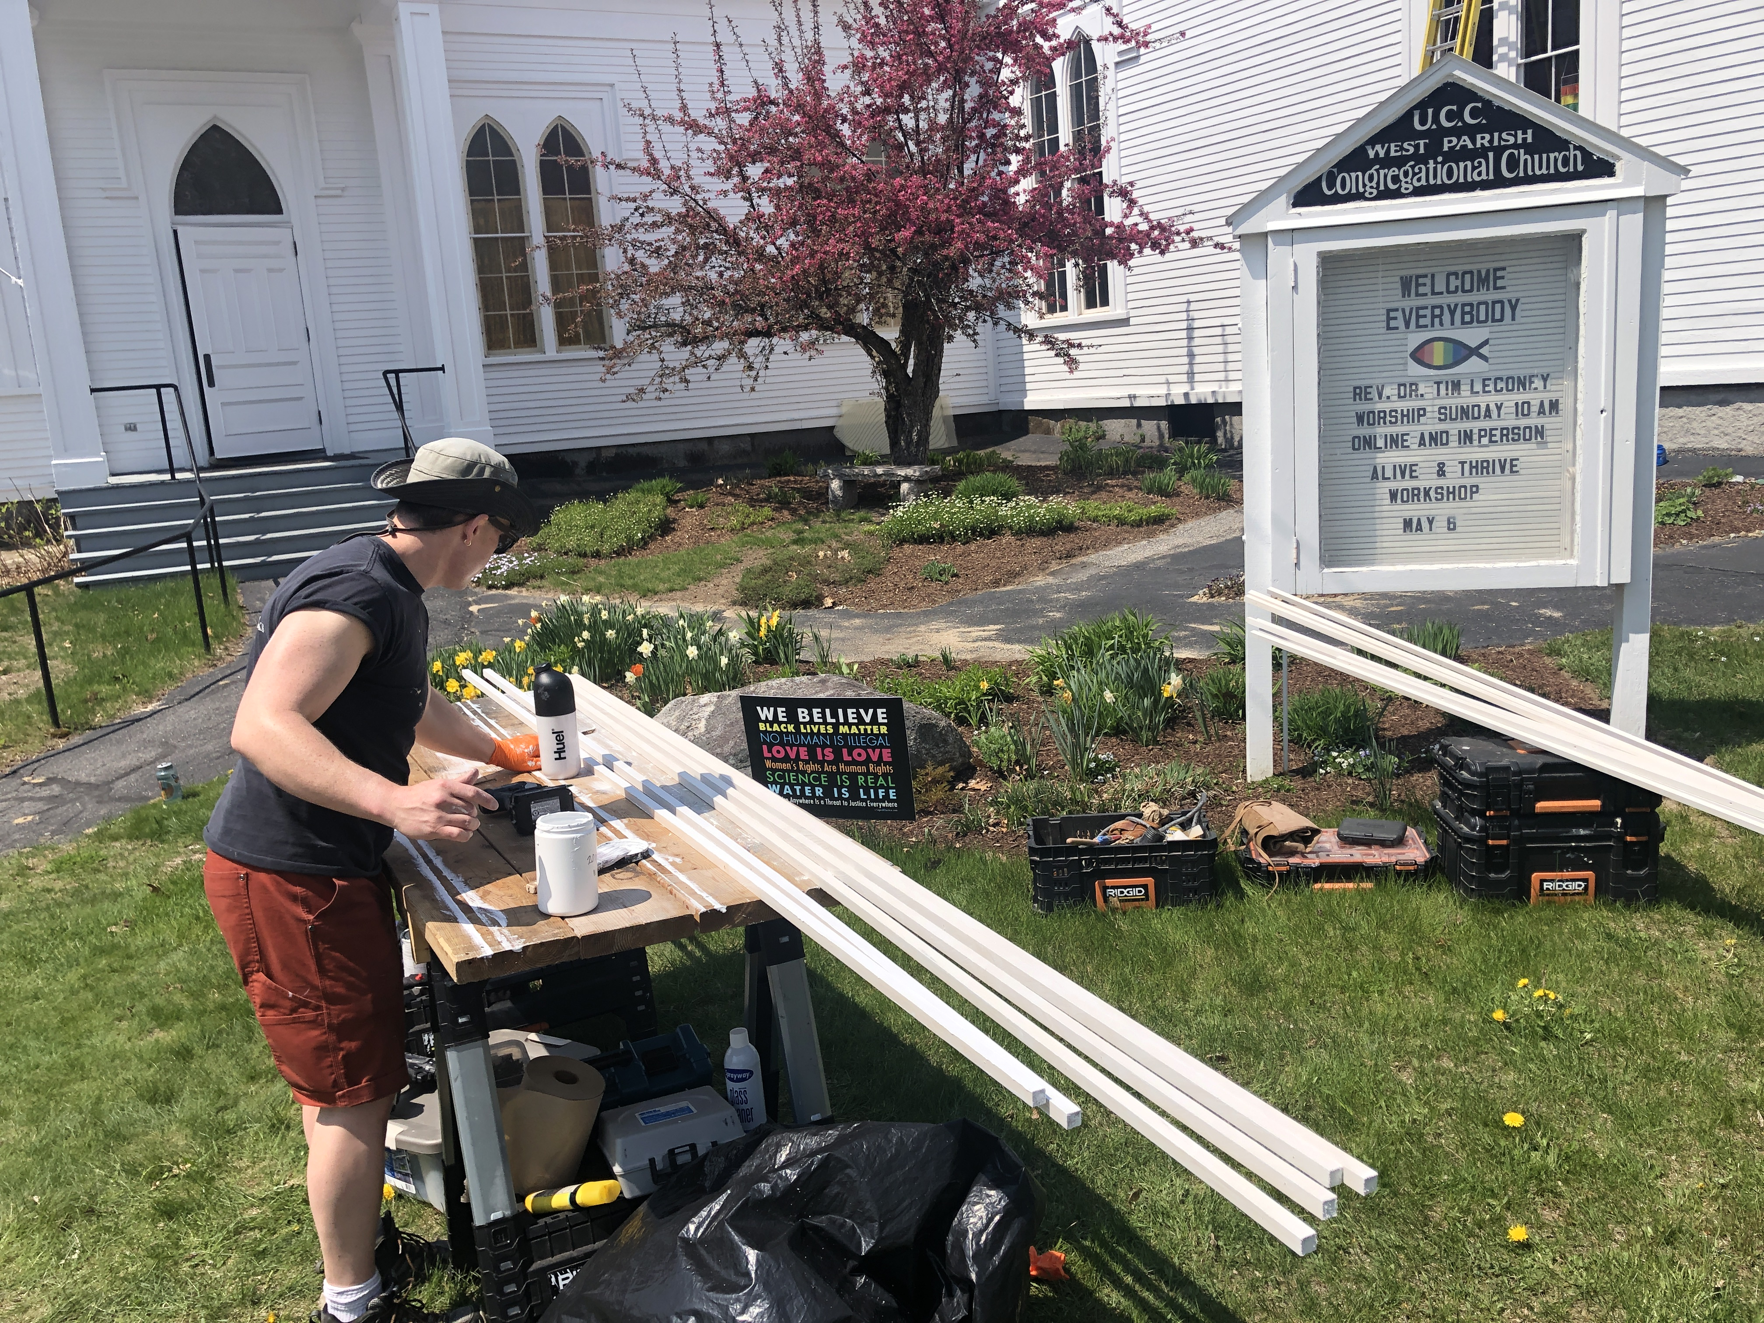

Updates - Ted shared how successful the window capital campaign has gone. We have 75% of the money has been committed within 2 months.



Share you Garden this summer – As the flower list is quite sparse, deacons want to have you share your garden each Sunday this summer. Jane will remind people with weekly updates. If anyone would like to take any of the remaining dates, please let Jane know.

Flower Duty Roster
May 21 - Jane
May 28 - Diane
June 4 -Youth Sunday – Sharon Lyon
June 11 - Ted
June 18 – Jane
June 25 – Iris
July 2 – Melinda and Diane

July 9 -
July 16 - Linda
July 23 - Sharon
July 30 -
Aug 6 -
Aug 13 - Jane
Aug. 20 - Melinda
Aug 27 - Sharon

Book group June
Book group will meet at Bob and Lida Iles' home, 132 Paradise Road, Bethel, Tuesday, June 6 at 7 PM.


This month we're discussing the book Black Cake by Charmaine Wilkerson. It describes the importance of traditions, like a recipe for the Caribbean fruitcake, which connects the family.
We welcome anyone who wants to come. Then book group will take a break for the summer.

Dates for June
Friday, June 2 Youth Group, 5-7 PM

Sunday, June 4 Children and Youth Sunday Worship with Communion, 10 AM/live streamed on YouTube Live

Tuesday, June 6 Prayer Group at 8:45 AM at church/on ZOOM; Book Group - 7 PM Bob and Lida Iles

Wed., June 7 Men’s Breakfast at 8 AM at church/on ZOOM

Friday, June 9–Monday, June 12 Rev. Tim on Vacation
Sunday, June 11 Worship at 10 AM with guest minister Associate Conference Minister
Alexis Fuller - Wright/live streamed on YouTube Live
Tuesday, June 13 Prayer Group at 8:45 AM at church/on ZOOM; Trustees at 6:30 PM on ZOOM

Wed., June 14 Christian Education Committee, 12 PM at church/on ZOOM; Memorial Service for Jim Owen, 2 PM

Thursday, June 15 Church Council, 6:45 PM on ZOOM

Sunday, June 18 Father’s Day; Worship at 10 AM/live streamed on YouTube Live

Tuesday, June 20 Prayer Group at 8:45 AM at church/on ZOOM
Wed., June 21 World Service Committee, 3 PM at church/on ZOOM; Music Committee, 4:30 PM on ZOOM

Sunday, June 25 Worship at 10 AM/live streamed on YouTube Live

Tuesday, June 27 Prayer Group at 8:45 AM at church/on ZOOM

Deacons Meeting - None in June or July. Next meeting is August 15


Birthdays for June
Take a few moments to wish these church friends a happy birthday and brighten up their day.

June 1 – Braden Scott
June 5 – Susie Dickerson
June 5 – Sarah DeCato
July 8 – Lucy Nordahl
June 10 – Ryder and Amy Scott
June 14 – Alex Baribeau
June 15 – Melody and Garrett Bonnema
June 16 – Ellen and Art Marshall
June 27 – Rahkiyah Dunham
June 27 – Jamie Doyle



Love Bowl for June
Strengthen the Church
A little love can go a long way. When our lives become unpredictable or chaotic, when we’re facing into a storm, when we’re weary and discouraged, fearful or confused… a little love can give the boost we need.
Many of us find that love in our church. But there are many people still seeking and yearning for a little love, a little hope, and a reassuring word. They have not found a church that’s reaching out with an extravagant welcome, where they can hear the message of the unconditional love of our still speaking God. That’s where the Strengthen the Church special mission offering steps in.
Each year, we receive a special offering that helps the church’s love to grow and thrive. Called Strengthen the Church, this offering funds new congregations and renews existing ones. It supports programs for youth and young adults and nurtures current and future leaders. And it sends the message of extravagant welcome and inclusiveness into our world. It is so important in this politically divisive time in the country.
We’re collecting the offering, appropriately in the Love Bowl for June, when we are encouraged to spread the word and spirit of God’s love.

Congratulations to Gaelan Boyle-Wight on his graduation from St. Michael's College!

